DBMS Technical Task
Dhanalakshmi K
E25AI110
BSc. Computer Science
With
Artificial Intelligence

Week 11: Database Automation using Views and Procedures
The e-commerce company frequently generates reports and performs repetitive database operations such as order processing, sales calculation, and customer analysis. To improve efficiency and reduce repeated SQL coding, the company wants to automate database operations using Views, Stored Procedures, and Functions.
- Create Views for Frequently Used Reports
A View is a virtual table created from one or more SQL queries. It stores the query definition and provides simplified access to frequently used information.
Tasks:
- Customer Order Report View
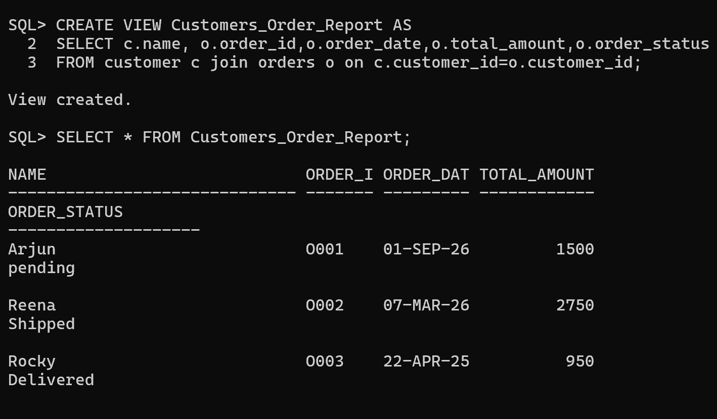
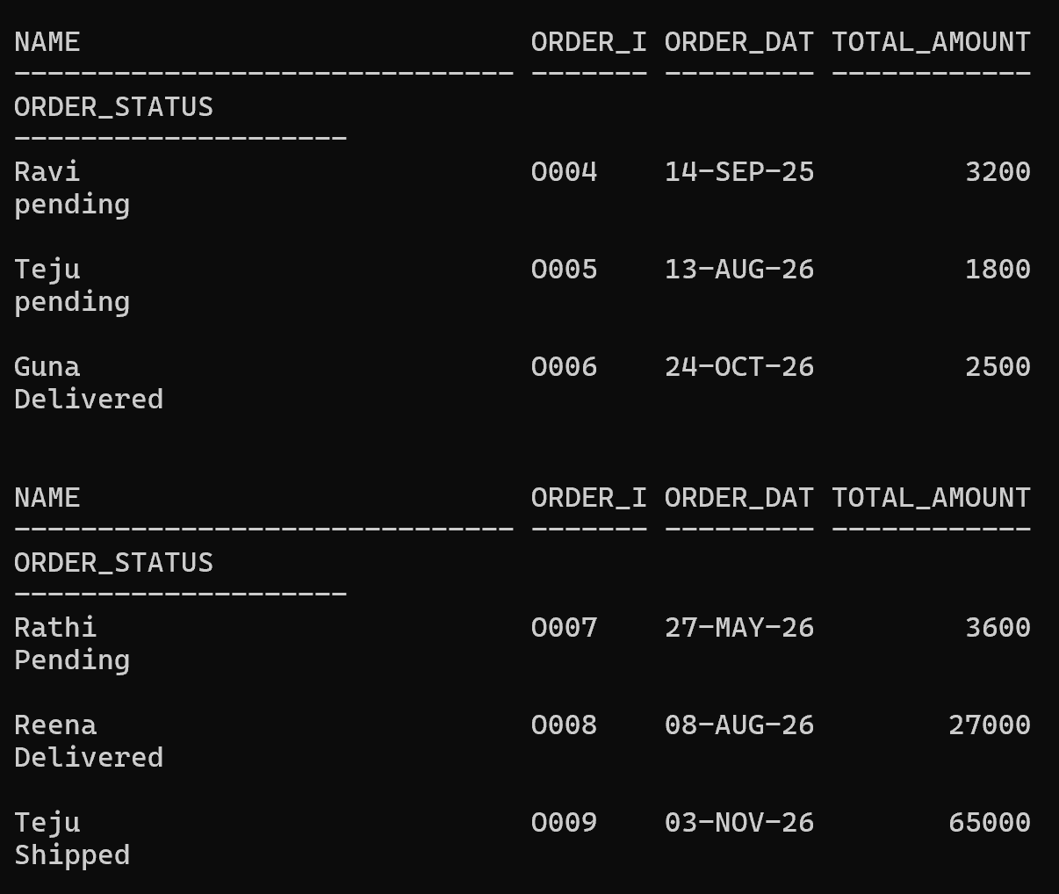
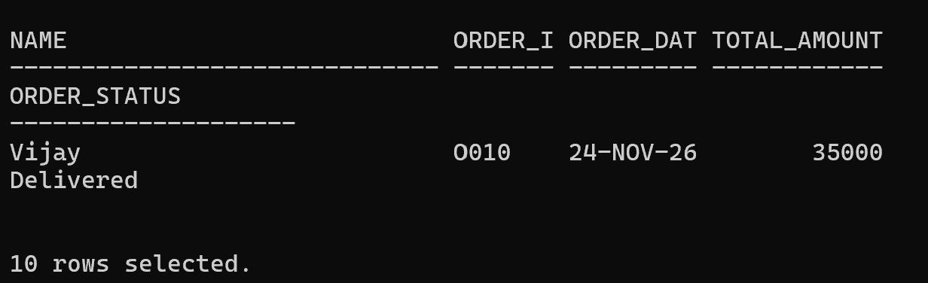
- Product Sales Report View
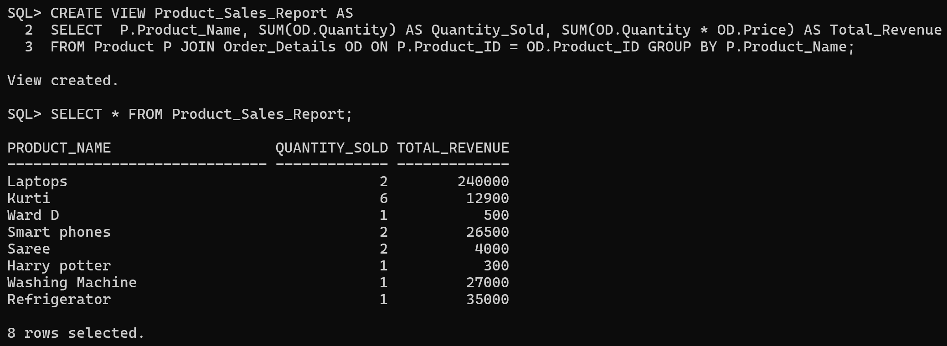
- Payment Status View
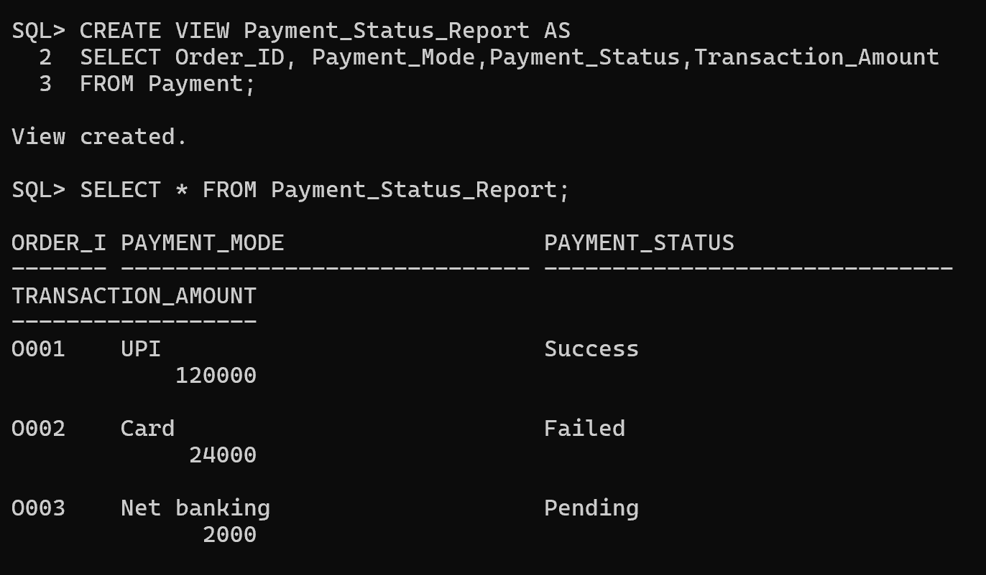
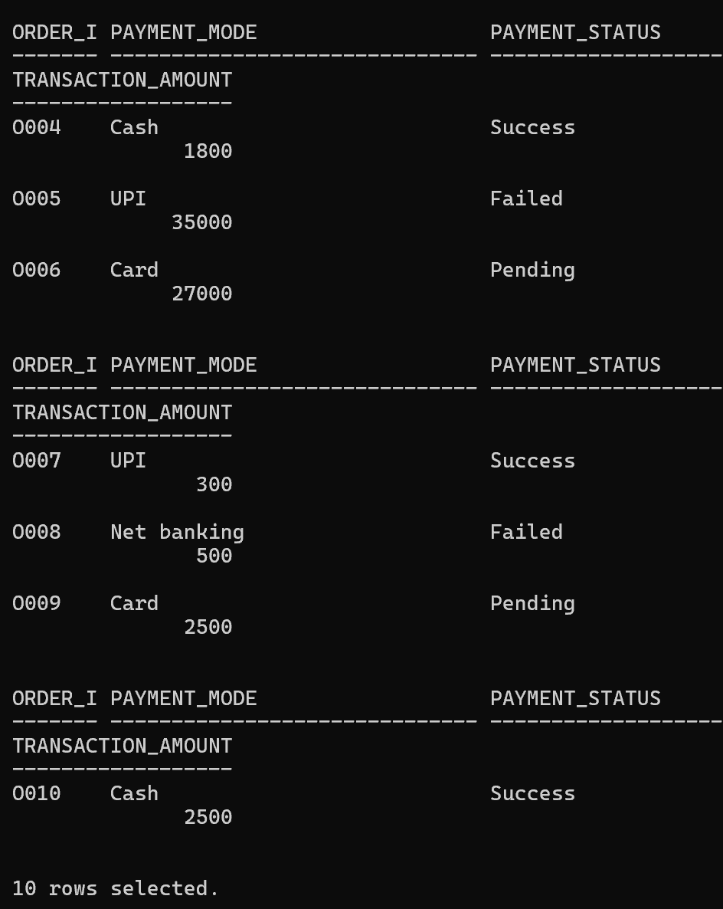

- Develop Stored Procedures for Order Processing
A Stored Procedure is a collection of SQL statements stored in the database that can be executed whenever required. It helps automate repeated operations.
Tasks:
- Add New Customer Order
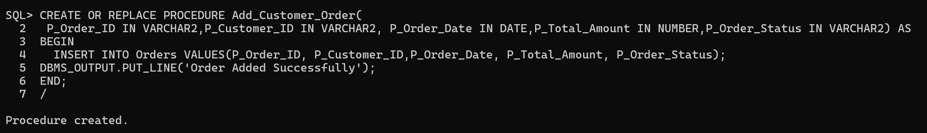
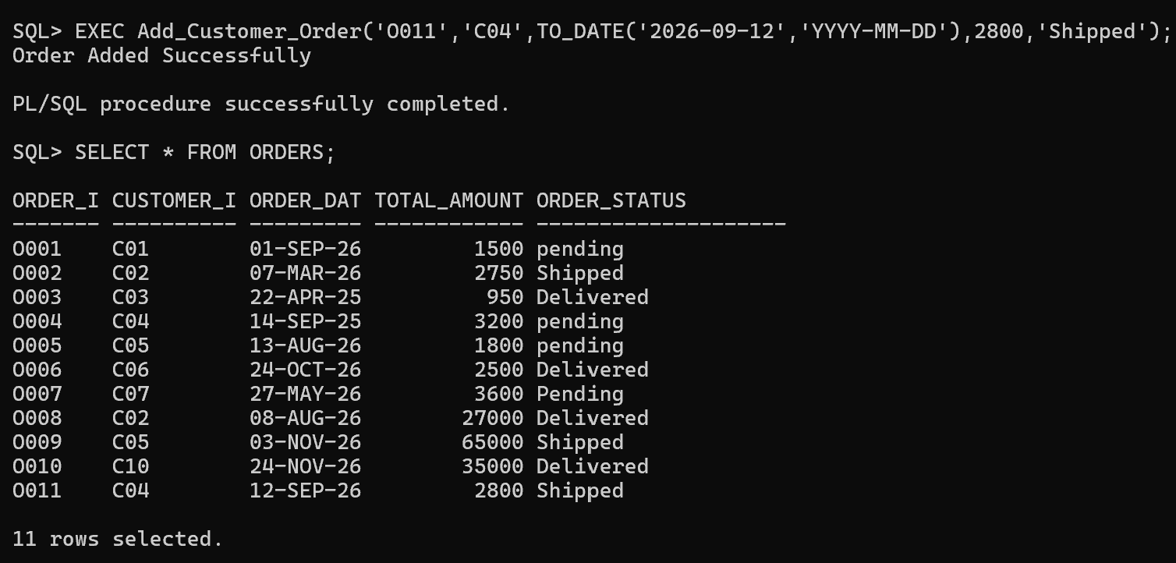
- Update Order Status
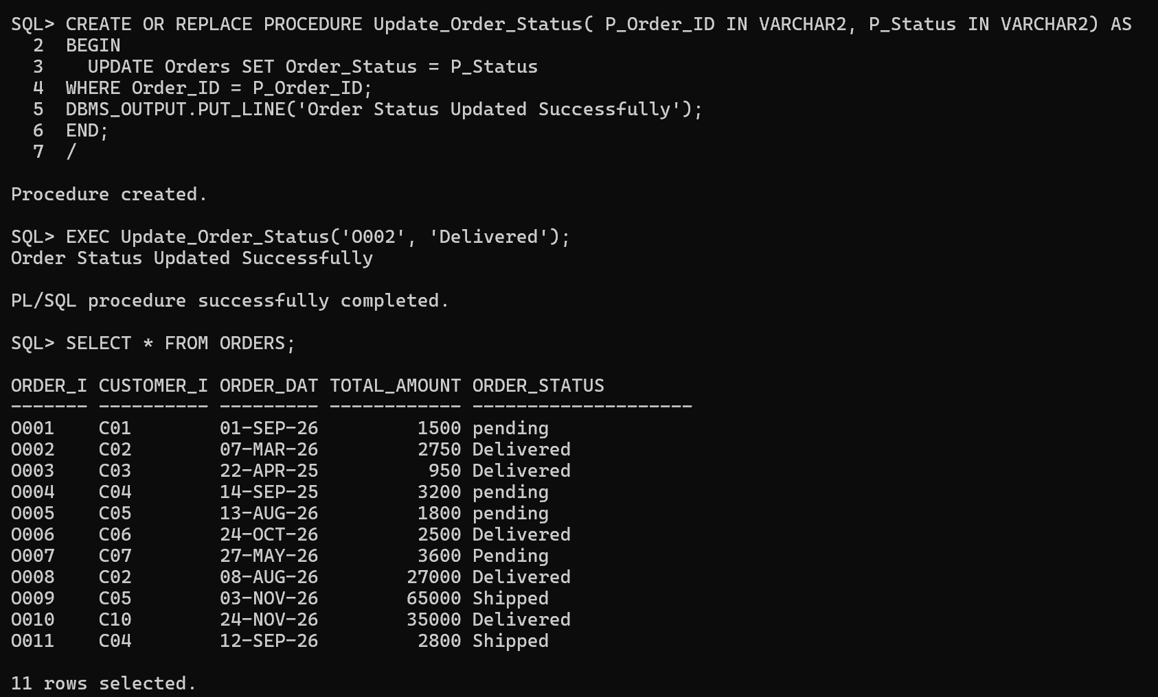
- Generate Customer Purchase History
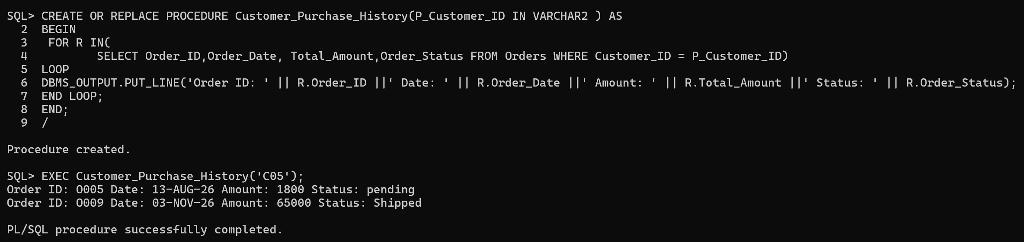

- Create Functions for Sales Calculations
Tasks:
- Calculate Total Sales
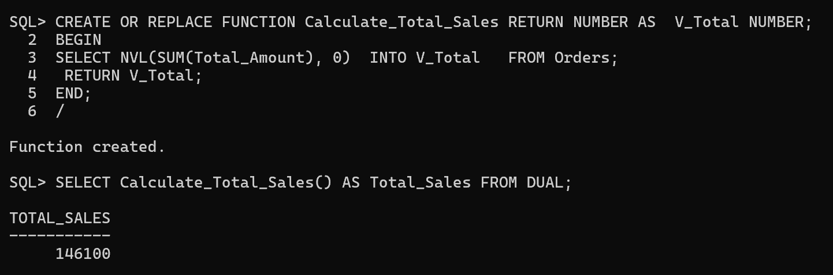
- Calculate Customer Total Spending
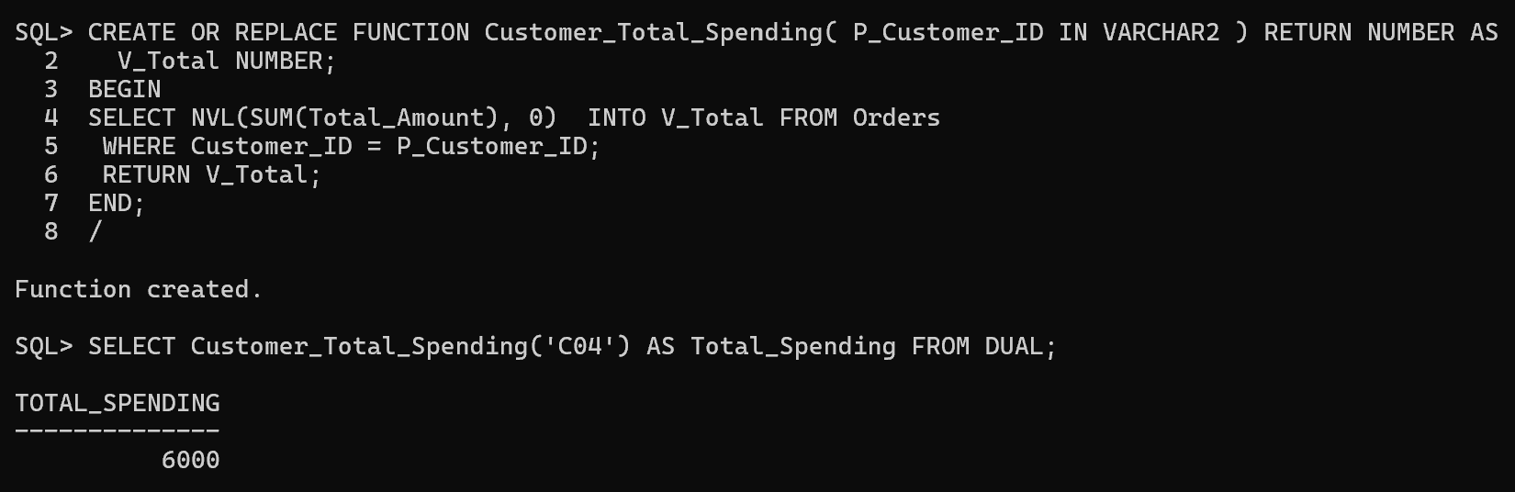
- Calculate Product Revenue
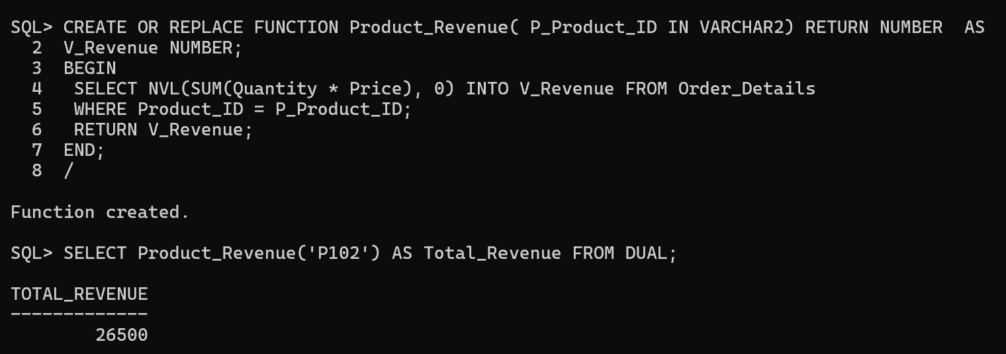

- Automate Repetitive Database Operations
Tasks:
- Order Processing Automation
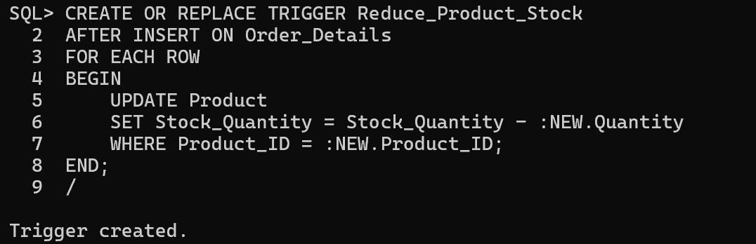
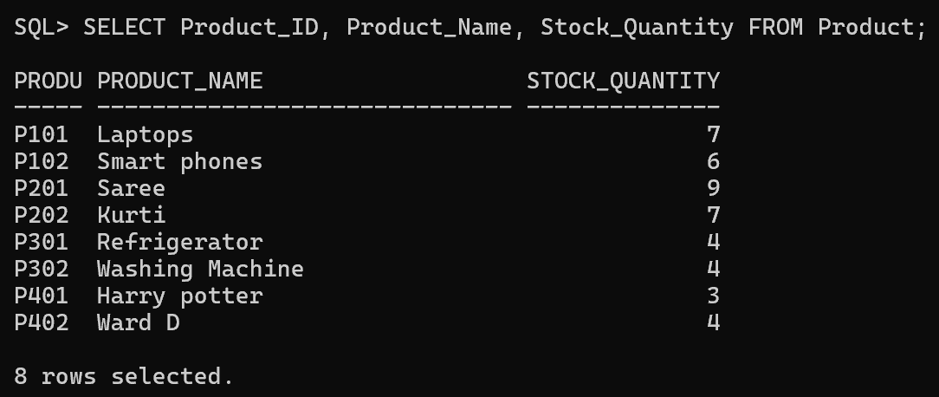
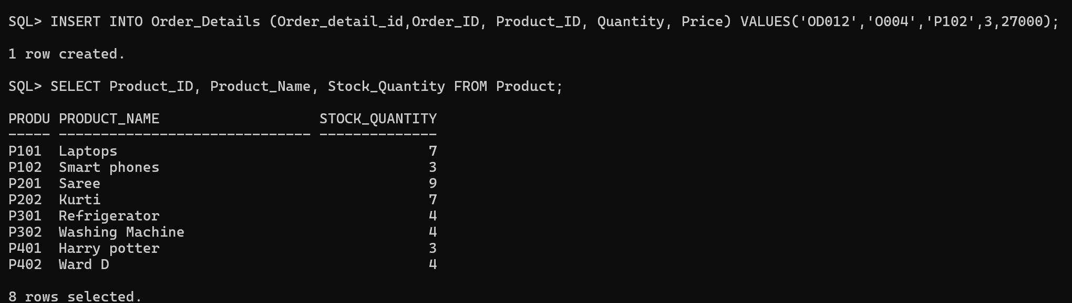
- Inventory Update Automation
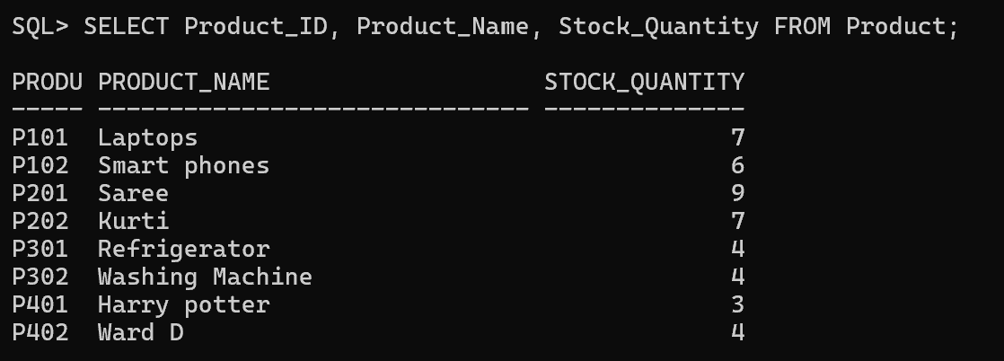
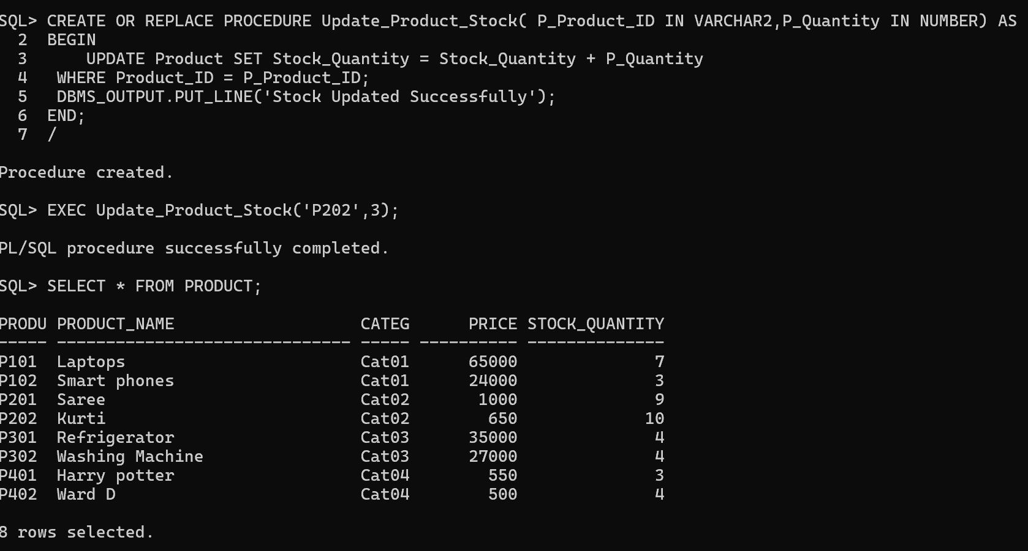
- Report Generation Automation
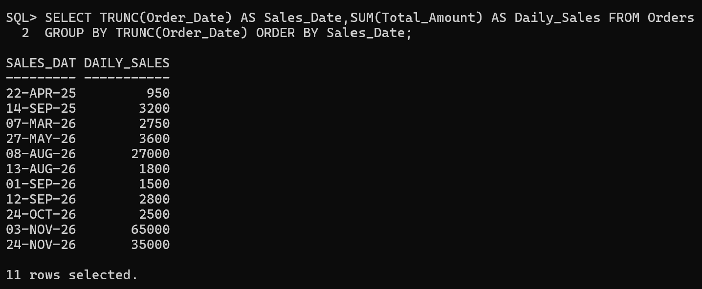

5.Test Database Objects
Tasks:
- Test view.
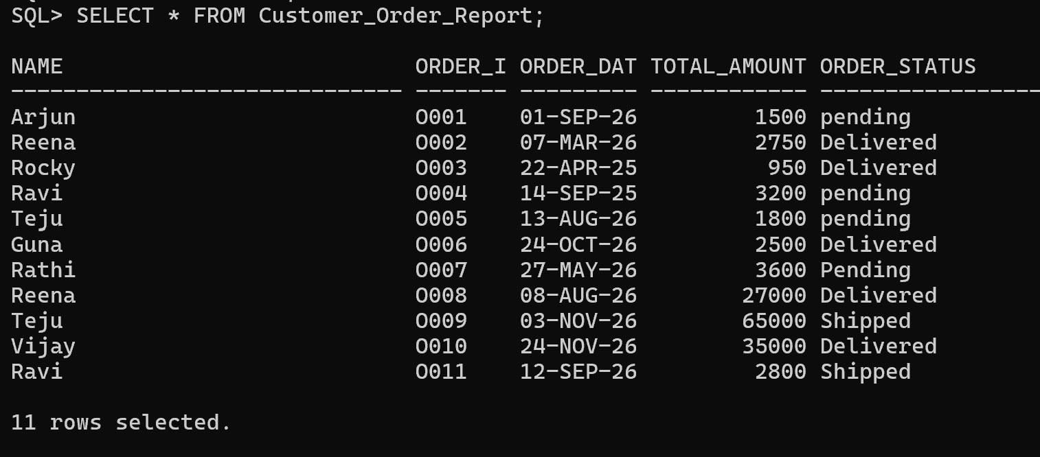
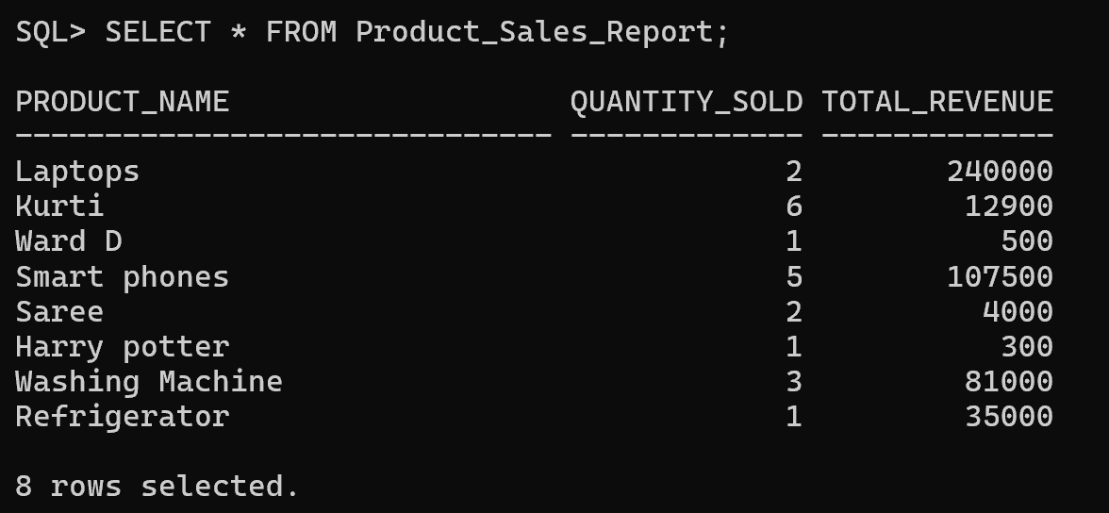
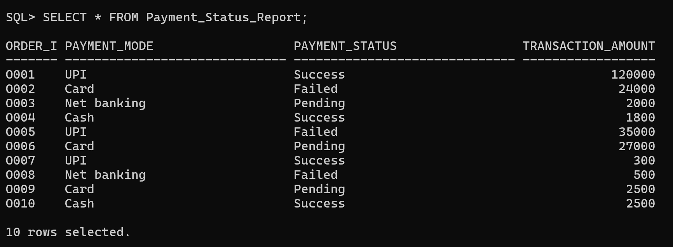

- Procedures Test:
- Procedure execution.
- Input parameters.
- Output results.
- Functions Verify:
- Calculation accuracy.
- Return values.


